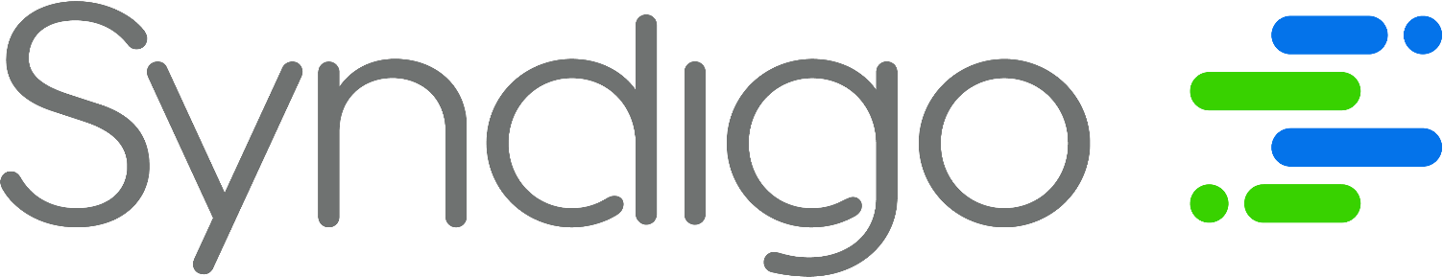

Enhanced Content Template #3: Banner Image with Image Widgets & Feature Sets
This template is intended for use by Syndigo SYAAS (Syndication as a Service) clients.
Submission of this template allows the SYAAS team to build your product’s Enhanced Content to your specifications. Please note that this is only one of several Enhanced Content Templates. If you are interested in exploring additional advanced widgets, or the templates provided to not align with your brand needs, please contact the SYAAS team.
To submit this template:
- Fill out all text fields within this template (including the Unique Identifier field).
- Fill out the SYAAS Request form, attaching this template and your assets to the appropriate fields.
- Click submit!

(Template begins on next page)

Please fill all below text fields.
Click here to see a preview example of this template.
Item’s Unique Identifier (GTIN, UPC, etc.):


File Name:
File Name:

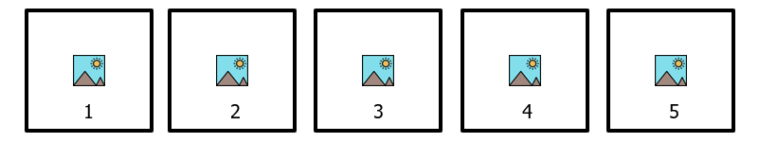
Image 1 File Name:

Image 2 File Name:

Image 5 File Name:
Image 4 File Name:
Image 3 File Name:

Insert Text Here:
File Name:
Insert Text Here:
File Name:

